1. List out all the Different Views in Android (Add code snippets and screenshots)
2. TextView

<TextView  
 android:id="@+id/mytextView"  
 android:layout_width="wrap_content"  
 android:layout_height="wrap_content"  
 android:text="Hello World!"  
 android:textColor="#1B1A1A"  
 android:textColorHighlight="#F0ECEC"  
 android:textSize="60sp"  
 app:layout_constraintBottom_toBottomOf="parent"  
 app:layout_constraintEnd_toEndOf="parent"  
 app:layout_constraintHorizontal_bias="0.598"  
 app:layout_constraintStart_toStartOf="parent"  
 app:layout_constraintTop_toTopOf="parent"  
 app:layout_constraintVertical_bias="0.484" />

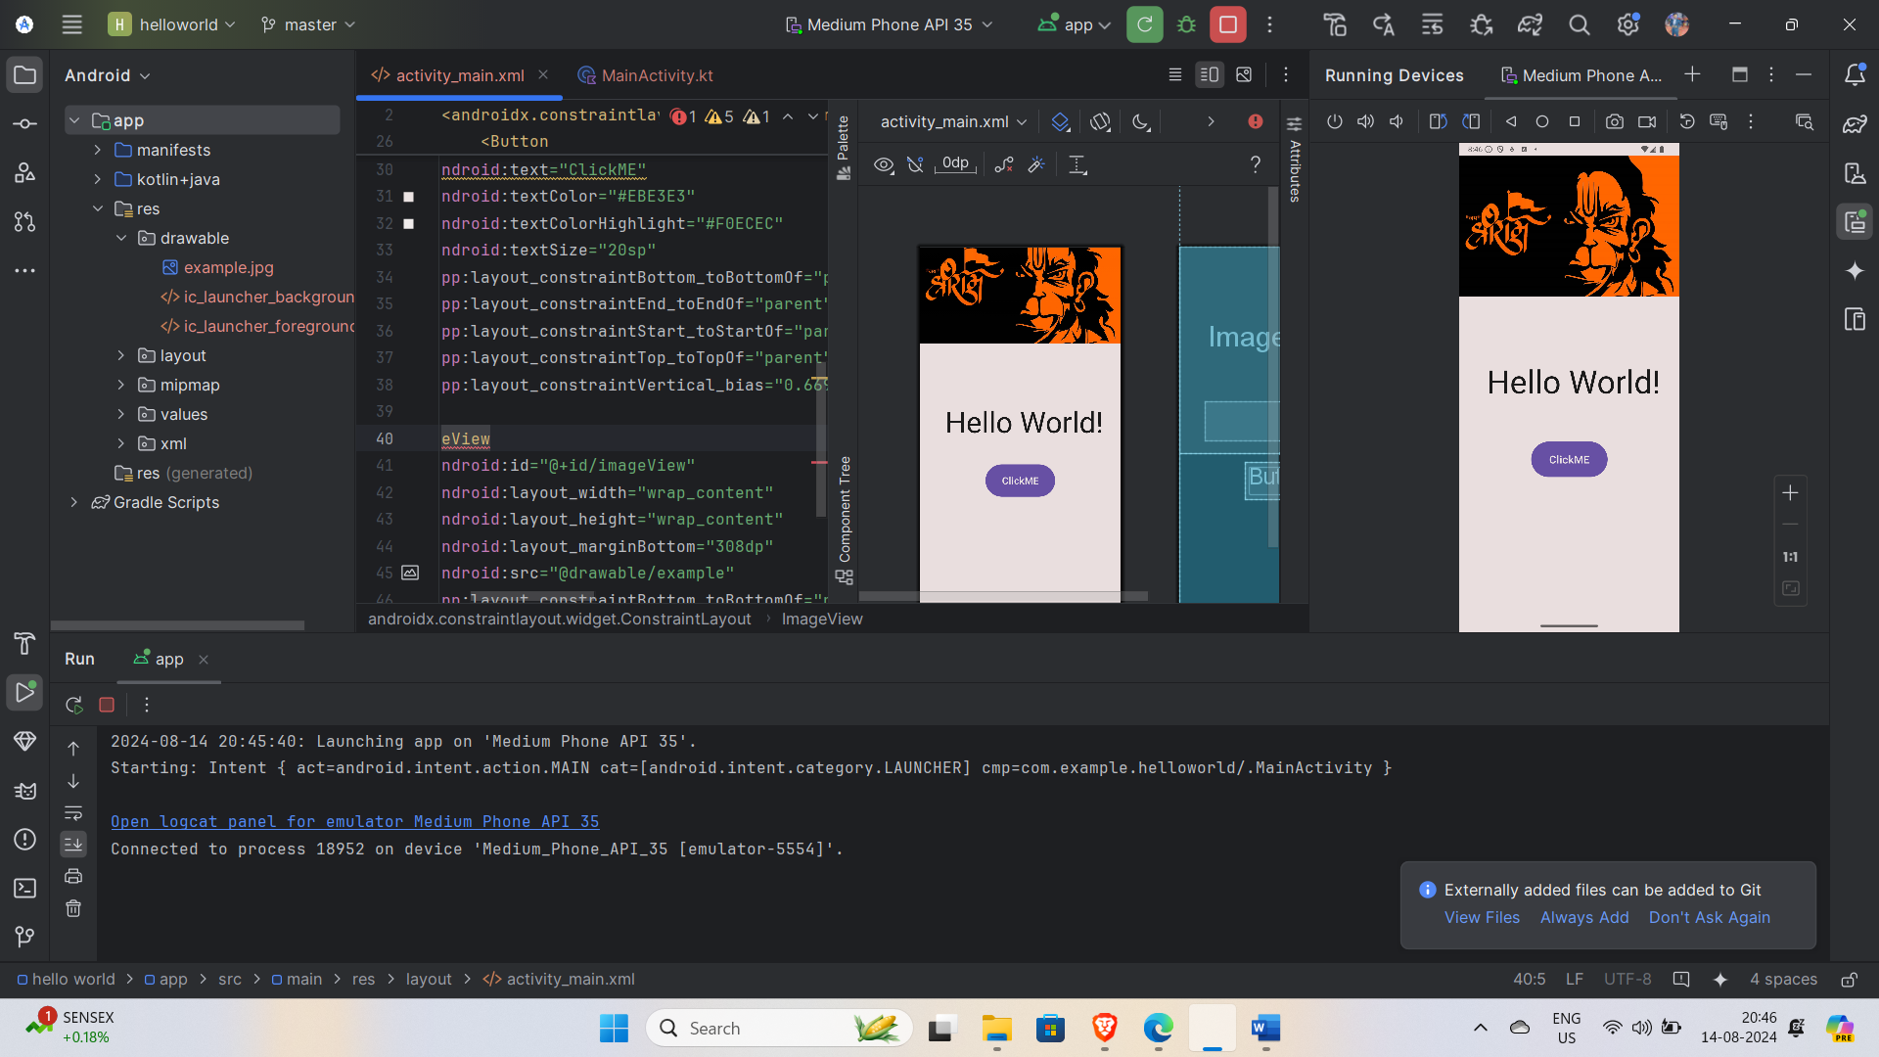

1. Button

<Button  
 android:id="@+id/my_button"  
 android:layout_width="143dp"  
 android:layout_height="74dp"  
 android:text="ClickME"  
 android:textColor="#EBE3E3"  
 android:textColorHighlight="#F0ECEC"  
 android:textSize="20sp"  
 app:layout_constraintBottom_toBottomOf="parent"  
 app:layout_constraintEnd_toEndOf="parent"  
 app:layout_constraintStart_toStartOf="parent"  
 app:layout_constraintTop_toTopOf="parent"  
 app:layout_constraintVertical_bias="0.669" />



1. ImageView

<ImageView  
 android:id="@+id/imageView"  
 android:layout_width="wrap_content"  
 android:layout_height="wrap_content"  
 android:layout_marginBottom="308dp"  
 android:src="@drawable/example"  
 app:layout_constraintBottom_toBottomOf="parent"  
 tools:layout_editor_absoluteX="0dp" />



4.CheckBox

<CheckBox  
 android:id="@+id/checkBox"  
 android:layout_width="158dp"  
 android:layout_height="76dp"  
 android:text="Check me"  
 android:textColor="@android:color/holo_red_dark"  
 android:textColorLink="#681D1D"  
 android:textSize="20sp"  
 app:layout_constraintBottom_toBottomOf="parent"  
 app:layout_constraintEnd_toEndOf="parent"  
 app:layout_constraintStart_toStartOf="parent"  
 app:layout_constraintTop_toTopOf="parent"  
 app:layout_constraintVertical_bias="0.9" />

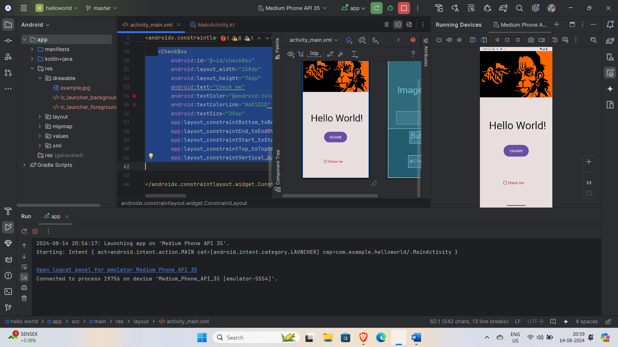

5.RadioButton

<RadioButton  
 android:id="@+id/radioButton1"  
 android:layout_width="wrap_content"  
 android:layout_height="wrap_content"  
 android:text="Option 1"  
 android:textColor="@android:color/holo_red_dark"  
 android:textSize="20sp"  
 app:layout_constraintBottom_toBottomOf="parent"  
 app:layout_constraintEnd_toEndOf="parent"  
 app:layout_constraintStart_toStartOf="parent"  
 app:layout_constraintTop_toTopOf="parent"  
 app:layout_constraintVertical_bias="0.783" />

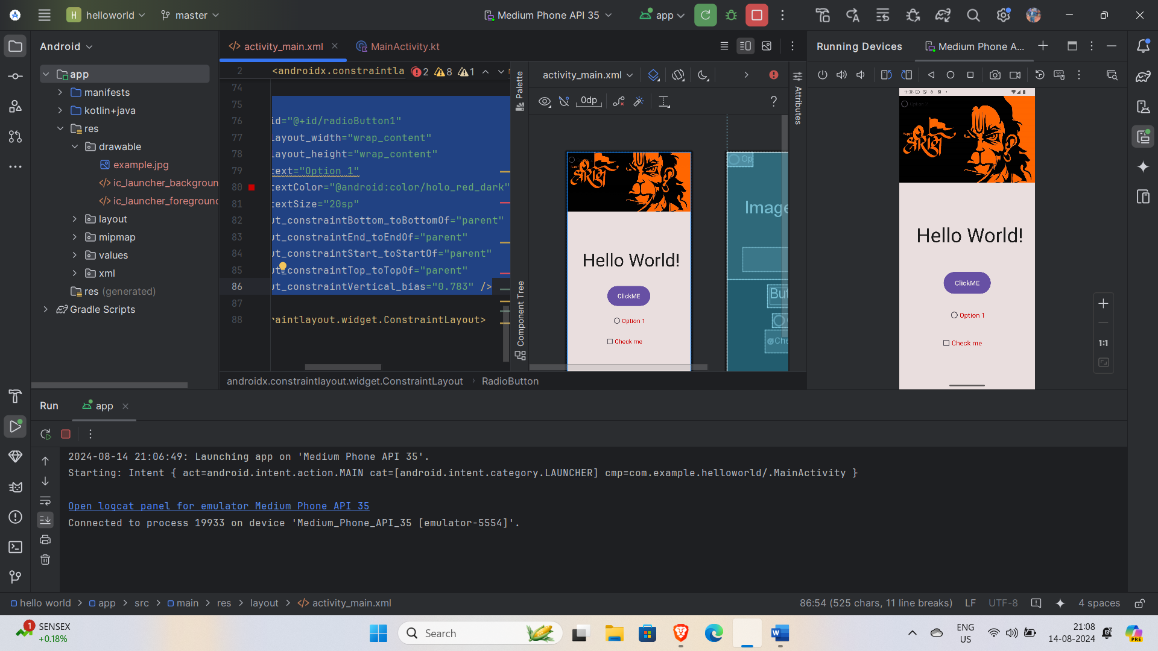

6.ProgressBar

<ProgressBar  
 android:id="@+id/progressBar"  
 android:layout_width="wrap_content"  
 android:layout_height="wrap_content"  
 android:layout_marginBottom="76dp"  
 android:indeterminate="true"  
 app:layout_constraintBottom_toBottomOf="parent"  
 app:layout_constraintEnd_toEndOf="parent"  
 app:layout_constraintHorizontal_bias="0.862"  
 app:layout_constraintStart_toStartOf="parent" />

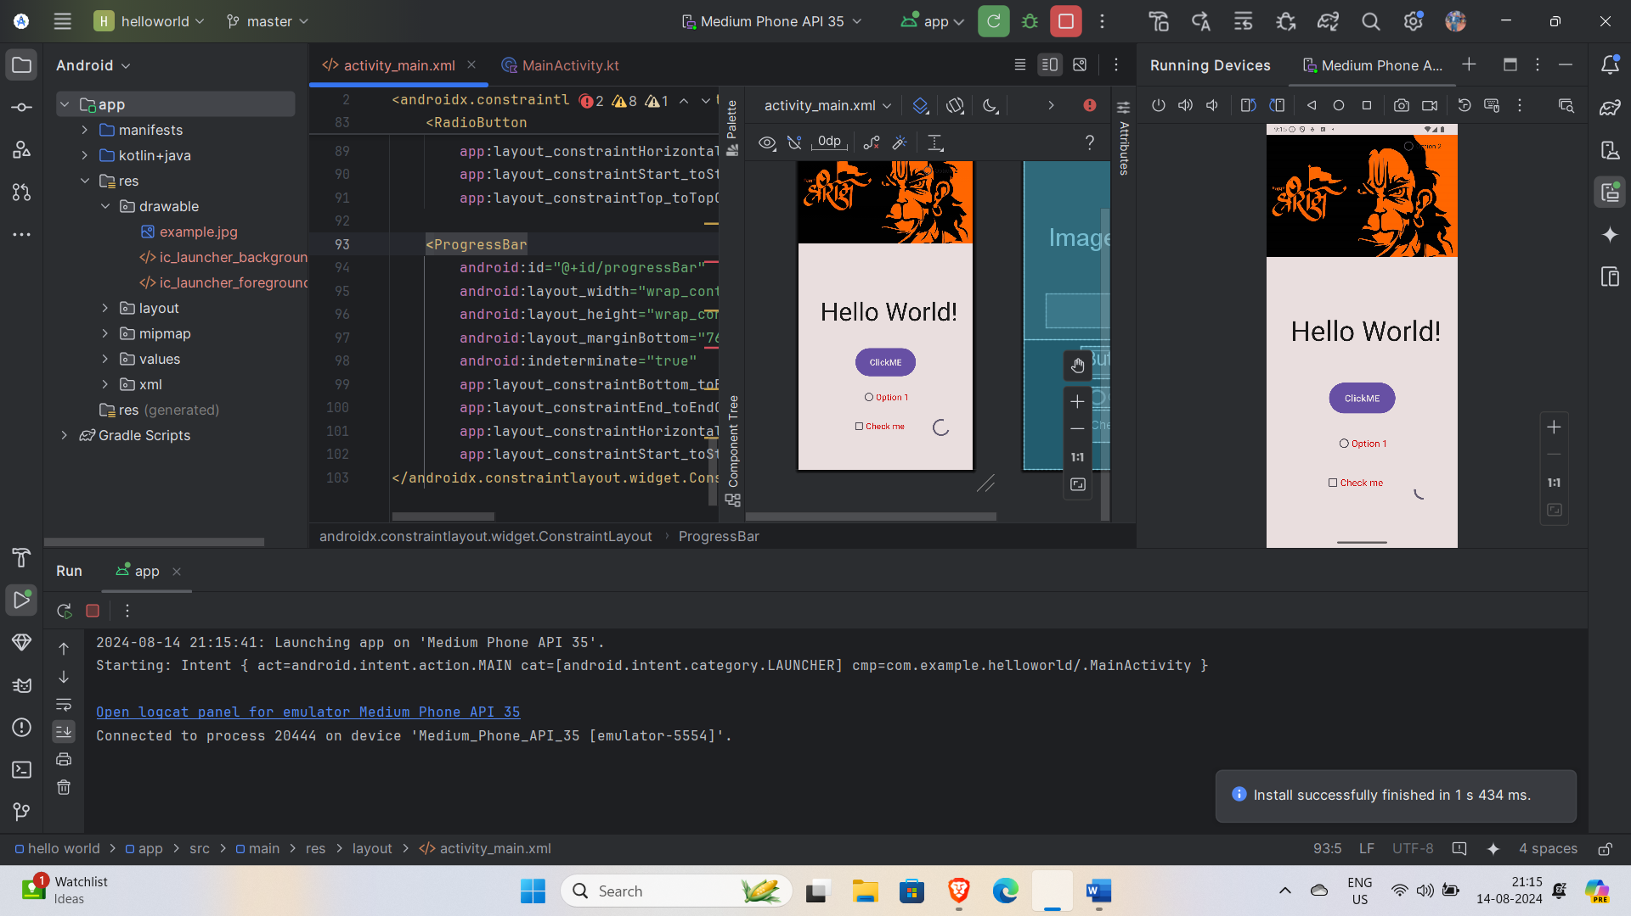

7.ScrollView

<ScrollView  
 android:layout_width="match_parent"  
 android:layout_height="match_parent"  
 app:layout_constraintBottom_toBottomOf="parent"  
 tools:layout_editor_absoluteX="-16dp">  
  
 <LinearLayout  
 android:layout_width="match_parent"  
 android:layout_height="wrap_content"  
 android:orientation="vertical">  
  
 <!-- Child views go here -->  
  
 </LinearLayout>  
</ScrollView>

8.CardView

<androidx.cardview.widget.CardView  
 android:id="@+id/cardView"  
 android:layout_width="wrap_content"  
 android:layout_height="wrap_content"  
 app:cardCornerRadius="8dp"  
 app:cardElevation="4dp"  
 app:layout_constraintBottom_toBottomOf="parent"  
 app:layout_constraintEnd_toEndOf="parent"  
 app:layout_constraintStart_toStartOf="parent"  
 app:layout_constraintTop_toBottomOf="@+id/mytextView">  
  
</androidx.cardview.widget.CardView>

